Multiple-choice section

|  |  |  |  |  |  |  |  |  |
| --- | --- | --- | --- | --- | --- | --- | --- | --- |
| Question | 1 | 2 | 3 | 4 | 5 | 6 | 7 | 8 |
| Answer | B | D | A | C | A | C | B | D |

Question 1 [4.6] [10A]

B

ax2 +bx + c = x2 – 2x + 4

a = 1, b = -2, c = 4

Question 2 [4.5] [10A]

D

7x2 + 20x – 32

= 7x2 + 28x − 8x – 32

= 7x(x + 4) − 8(x + 4)

= (7x − 8)(x + 4)

Question 3 [4.6] [10A]

A

x = 5 and x = -2

x – 5 = 0 and x + 2 = 0

(x – 5) and (x +2) are factors

(x – 5)(x + 2) = 0

Question 4 [4.6] [10A]

C

As each factor can be equated to 0, the null factor law is the quickest way to solve this equation.

Question 5 [4.2]

A

x2 + 6x + 2

= x2 + 6x +  –  + 2

= x2 + 6x + 9 – 9 + 2

= (x + 3)2 – 7

= (x + 3 +  )(x + 3 – )

Question 6 [4.4]

C

y = x2 + 3x – 4

y = 02 + 30 – 4

y = -4

Question 7 [4.1]

B

Use the null factor law.

x(x – 3) = 0

 or x – 3 = 0

x = 0 or 3

Question 8 [4.4]

D

y = (x – h)2 + k where the turning point is located at (h, k). The turning point is (-2, -6).

Multiple-choice total marks: 8

Short answer section

Question 9 9 marks [4.1, 4.3]

(a) x(x – 7) = 0

x = 0 or x – 7= 0

x = 0 or 7

(b) (x − 2)(x + 4) = 0

x – 2 = 0 or x + 4 = 0

x = 2 or x = -4

(c) 64 – 49x2 = 0

(8 – 7x) (8 + 7x) = 0

8 – 7x = 0 or 8 + 7x = 0

7x = 8 or 7x = -8

x = 

(d) x2 + 5x + 5 = 0

(x2 + 5x + ) –  + 5 = 0

(x + )2 – = 0

(x +  – )(x +  +) = 0

x +  – = 0 or x +  += 0

x = -  +  or x = -  – 

x = -   

Question 10 4 marks [4.1]

(a) 1 8 = 8 and 1 + 8 = 9

x2 + 9x + 8 = (x + 8)(x + 1)

(b) (x + 8)(x + 1) = 0

x + 8 = 0 or x + 1 = 0

x = -8 or x = -1

Question 11 6 marks [4.1]

|  |  |
| --- | --- |
| (a) 8 × -3 = 24, 8 + -3 = 5 x2 + 5x – 24 = (x + 8)(x – 3)  (b) Dimension= x + 8 or x – 3 x − 3 = 4  Length = 13 cm, Width = 2 cm 16 + 8 = 24  Length = 24 cm, Width = 13 cm | (c) Area = lw  For x = 5, Area = 13 × 2  = 26 cm2  For x = 16, Area = 24 × 13  = 312 cm2 |

Question 12 3 marks [4.2]

x2 – 8x + 11

= x2 – 8x + 16 – 16 + 11

= (x2 – 8x + 16) – 5

= (x – 4)2 – 5

= (x – 4)2 – ()2

= (x – 4 + )(x – 4 – )

Question 13 5 marks [4.2, 4.3, 4.4]

(a) x2 + 8x + 13  
= x2 + 8x + 16 – 16 + 13  
= (x2 + 8x + 16) – 3  
= (x + 4)2 – 3

(b) (-4, -3)

(c) x-intercepts when y = 0

(x + 4)2 – 3 = 0

(x + 4 + **)(x + 4 − **) = 0

x = -4 **

x-intercepts: (-4 + **, 0) and (-4 − **, 0)

Question 14 4 marks [4.6] [10A]

(a) x2 + 2x + 8 = 0

x = **

= **

As ** has no real value, there are no real solutions.

(b) 3x2 – 5x – 12 = 0

x = **

= **

As ** can be evaluated, there are solutions.

Question 15 3 marks [4.6] [10A]

5y2 + 15y – 4y – 12 = 0

5 × -12 = -60

Find factors of -60 with a sum of +11.

Use 15 and -4.

5y2 + 15y – 4y – 12 = 0

5y(y + 3) – 4(y + 3) = 0

(5y – 4)(y + 3) = 0

y = , y = -3

Question 16 3 marks [4.4]

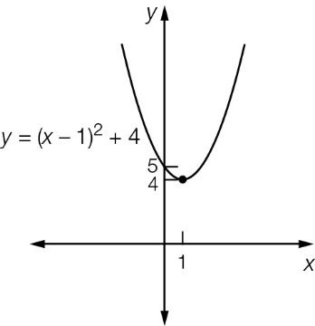

Question 17 3 marks [4.4]

Turning point is at (h, k) = (8, 3)

For x = 7:  


-2 = a + 3

a = 5

Short answer total marks: 40

Extended answer section

Question 18 6 marks [4.4]

(a)

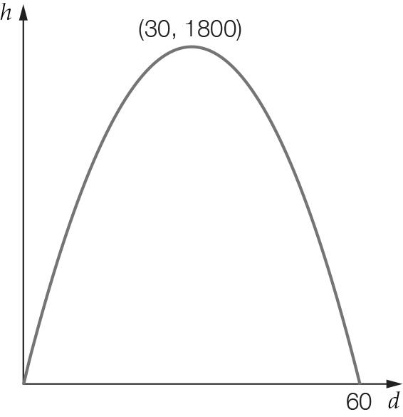

(b) Maximum height at turning point (30, 1800). So maximum height = 1800 m

(c) Where y = 0:

-2(d – 30)2 + 1800 = 0

d – 30)2 – 900 = 0

(d – 30 + 30)(d – 30 – 30) = 0

d = 0 or 60

Distance to target = 60 km

Question 19 9 marks [4.2, 4.3, 4.4]

(a)

|  |  |  |  |  |  |  |  |  |  |
| --- | --- | --- | --- | --- | --- | --- | --- | --- | --- |
| ***x*** | 0 | 1 | 2 | 3 | 4 | 5 | 6 | 7 | 8 |
| ***y*** | 0 | 7 | 12 | 15 | 16 | 15 | 12 | 7 | 0 |

(b)

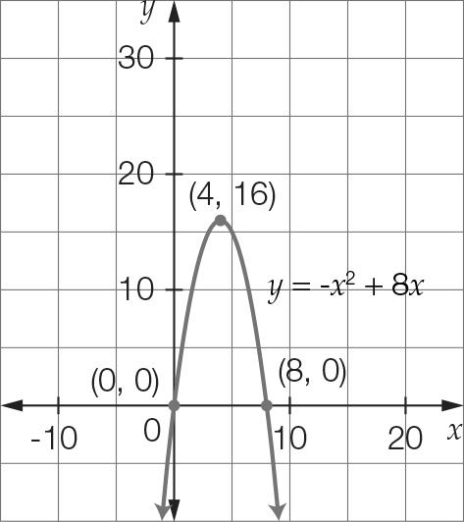

(c) (i) (4, 16) (ii) x-intercepts are (0, 0) and (8, 0); y-intercept is (0, 0).

(d) -x2 + 8x – 7 = 0  
= (x – 7)(x – 1) = 0

The ball was at a height of 7 m, 1 second and 7 seconds after the ball was thrown.

(e) There are two times, on the way up and on the way down.

(f) The ball reaches a maximum height of 16 m. It does not reach the 17 m level.

Extended answer total marks: 15

TOTAL test marks: 63